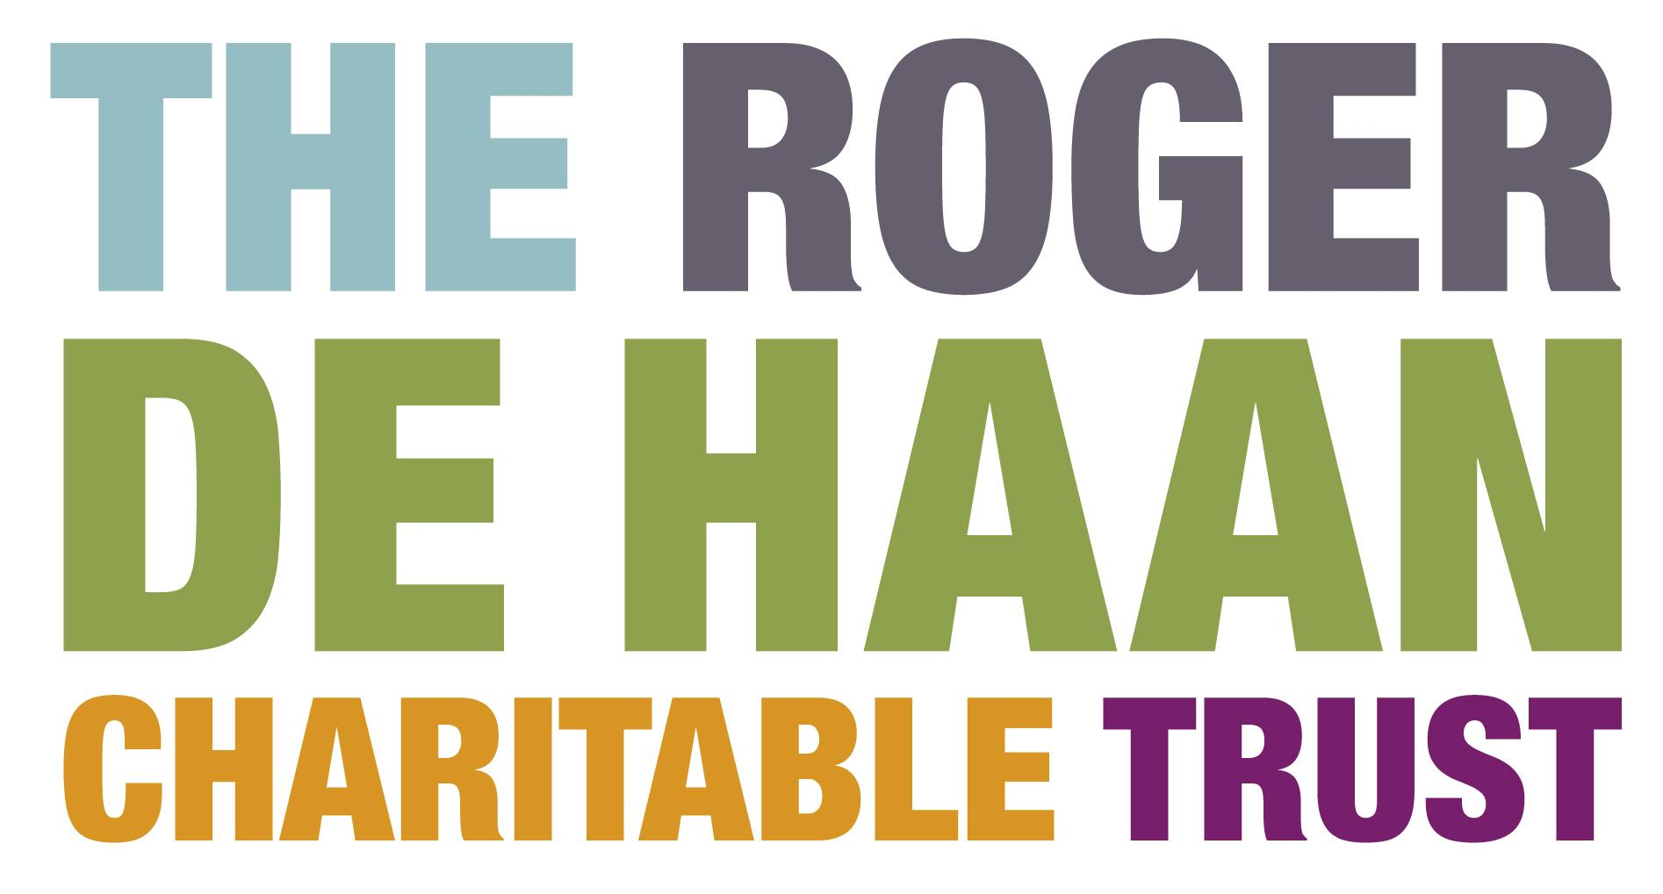

**Festivals Fund Application Form**

**YOU ARE INVITED TO RESPOND TO THE QUESTIONS IN THIS SECTION EITHER IN WRITING OR WITH A SHORT VIDEO/SOUND FILE.** We do not have a format preference and the recorded version should have the same content as if it were written. No assessment of the production quality of audio or video recordings will be made.

|  |  |  |
| --- | --- | --- |
| **1.** | **Name of lead applicant** |  |
| **2.** | **Name of festival** |  |
| **3.** | **Name of your organisation, company or group if applicable** |  |
| **4.** | **How are you or your group formally constituted?** |  |
| **5.** | **Address** |  |
| **6.** | **Contact telephone number** |  |
| **7.** | **E-mail address** |  |
| **8.** | **How much money are you applying for (up to £5,000)?** |  |
| **8.** | **When will your festival or project take place?** |  |
| **9.** | **Where will your project take place?** |  |
| **10.** | **Tell us about yourself and your experience of managing events (max 250 words)** |  |
| **11.** | **Please provide a description of your festival or project (max 250 words)** |  |
| **12.** | **Please describe how you will manage the festival or project (max 250 words)** |  |
| **13.** | **How many people do you hope to attract as audience?** |  |
| **14.** | **How many people do you hope to involve overall and how will they take part?** |  |
| **15.** | **Please describe your marketing & PR campaign (max 250 words)** |  |
| **16.** | **What is the total cost of your project? Please provide a simple budget** |  |
| **17.** | **What other funding do you have or hope to have in place?** |  |
| **18.** | **How will you evaluate the success of your festival or project? (max 250 words)** |  |
| **19.** | **Please tell us who the payment will be made out to if your application is successful** |  |

**Signed by lead applicant: Date:**

Please email your completed application form, or send a link, along with the attached Equal Opportunities Monitoring Form by the appropriate deadline to [owenkimm@creativefolkestone.org.uk](mailto:owenkimm@creativefolkestone.org.uk)

We aim to assess applications and inform you of the outcome within 2 weeks.